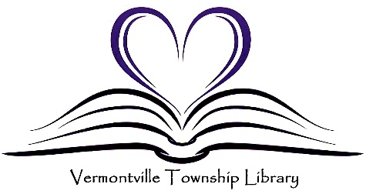
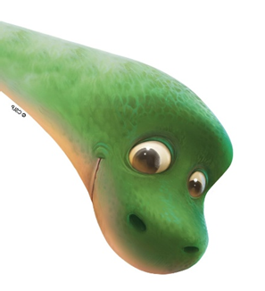



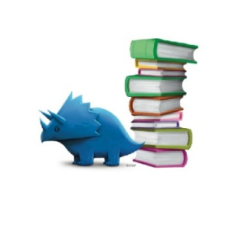
Registration starts May 15, 2026.
Pick up Reading Challenge materials beginning June 2.
This action-packed summer program is designed to keep kids learning, laughing, and moving all season long!
The fun begins with an exciting Foam Party, where kids can dance, play, and cool off in piles of fluffy foam while enjoying music, games, and a lively, festival-like atmosphere.
Next, young adventurers dive into Dinosaur Discovery Days, exploring the prehistoric world through hands-on activities like fossil digs, dinosaur crafts, footprint tracking, and interactive games that bring these ancient creatures to life.
Adding a nature-focused twist, kids will also explore the world beneath their feet in Roots & Rocks Exploration. Through hands-on activities, they’ll study root plants like carrots and flowers, learn how roots grow and function, and make their own garden stone. Activities include planting, observing root systems, and creating a worm farm.
Adding even more excitement, a Magician/Comedian takes the stage to wow kids with incredible tricks, silly humor, and plenty of audience participation—guaranteed to have everyone laughing and amazed.
Throughout the program, kids can also participate in a Reading Challenge with prizes, encouraging them to build strong reading habits while having fun. As they track their reading progress, they’ll earn rewards, and earn fun prizes that keep them motivated all summer long.
This well-rounded program blends entertainment, education, and creativity—giving kids a summer full of unforgettable memories, new skills, and lots of laughter.
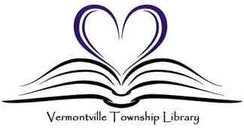

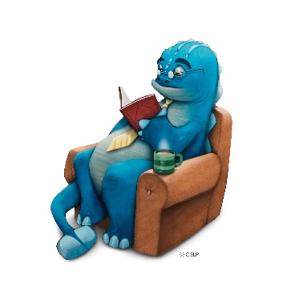
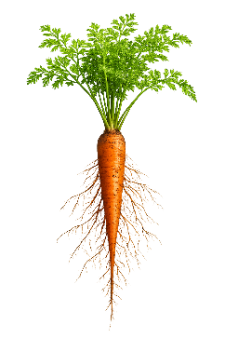


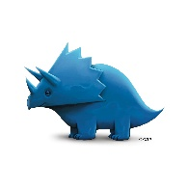
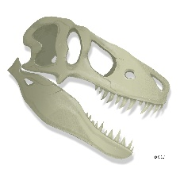
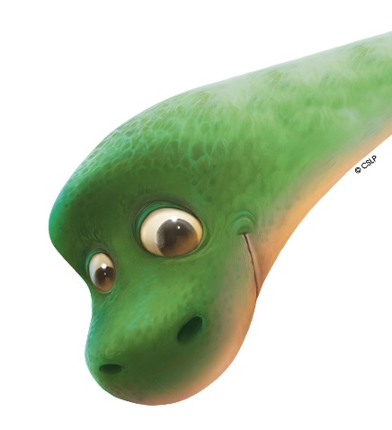
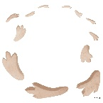

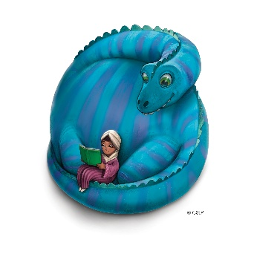
July 21—Cameron Zvara
Kick Off—June 9
Get ready for the ultimate high-energy experience with a foam party event! This exciting, interactive celebration transforms any space into a bubbly wonderland filled with mountains of cool, fluffy foam. As music pumps through the speakers, guests dance, laugh, and play in a sea of suds, creating a one-of-a-kind party atmosphere that’s both refreshing and unforgettable.
June 16—Roots & Rocks
This engaging, hands-on program invites participants to dig beneath the surface and discover the hidden world that helps gardens thrive. Focusing on plant roots, garden rocks, and worm farms, the experience blends science, exploration, and practical skills to show how healthy soil systems work from the ground up.
Join us for an evening of AMAZEMENT & FUN with Comedy Magician & Entertainer- Cameron Zvara! Cameron's show is filled with mind blowing magic, squeaky clean comedy, and tons of audience participation. You do not want to miss out!”
Celebrate America’s 250th birthday with a party and a red-white- and blue color run. Remember to wear white!!
July 7—Happy Birthday America!
The program begins with dinosaur night lights, where participants create their own glowing keepsakes. Using simple materials and dinosaur-themed designs, they’ll craft a light that brings a prehistoric touch to any room while learning about different dinosaur species along the way. Participants will explore T. rex footprints, discovering how scientists use tracks to understand how dinosaurs moved, their size, and their behavior.
June 30—Tiny Dinos & Big Footprints
This exciting, hands-on program takes participants on a journey back in time to explore the world of dinosaurs and Earth’s ancient past. Combining science, creativity, and a bit of messy fun, the experience brings history to life in a way that’s engaging for all ages.
June 23—Fossil Finds & Noodle Bones
All programs begin at 6:30 PM at the Vermontville Village Park
Dinosaur Olympics is a high-energy, action-packed program that turns participants into prehistoric champions as they compete in a series of fun, dinosaur-themed games and challenges.
July 14—Dinosaur Olympics

