
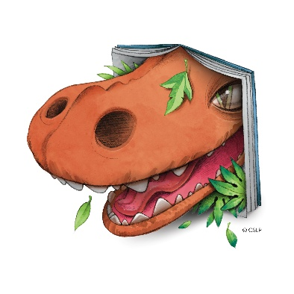
Vermontville Township Library
2026 Summer Reading Program


I give permission for ________________________________________________
to participate in the Vermontville Township Library 2026 Summer Reading Program—Unearth a Story. I am aware that the library events will be taking place at the Vermontville Community Center or the Village Park.
Parent or Guardian Signature: ______________________________________________________ Date: ____________
Age_________ grade for next school year _____________ Independent Reader ___________pre-reader_____________
I plan on participating in the reading challenge ______yes _____no
I plan on attending events only _____yes ______no
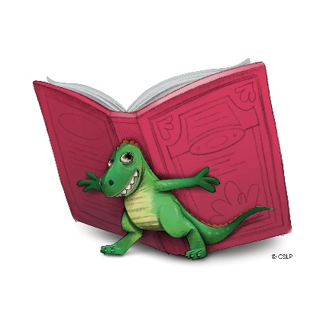
Permission to Videotape and/or Photograph

I _______________________________________ am the parent or legal guardian of______________________________
I understand the Vermontville Township Library may photograph or videotape the events or activity in which I am (or my child is) participating. I give my permission for the Vermontville Township Library to use photographs or videotape of me (or my child) for the purpose of promoting the Vermontville Township Library and its services/programs. I give my permission with the following understanding: No compensation of any kind will be paid to me (or my child) at this time or in the future for the use of my (or my child’s) likeness.

Permission is not required to take part in library events.
Signature: ________________________________ Date: ____________________

